

Master of Applied Management
Level 8
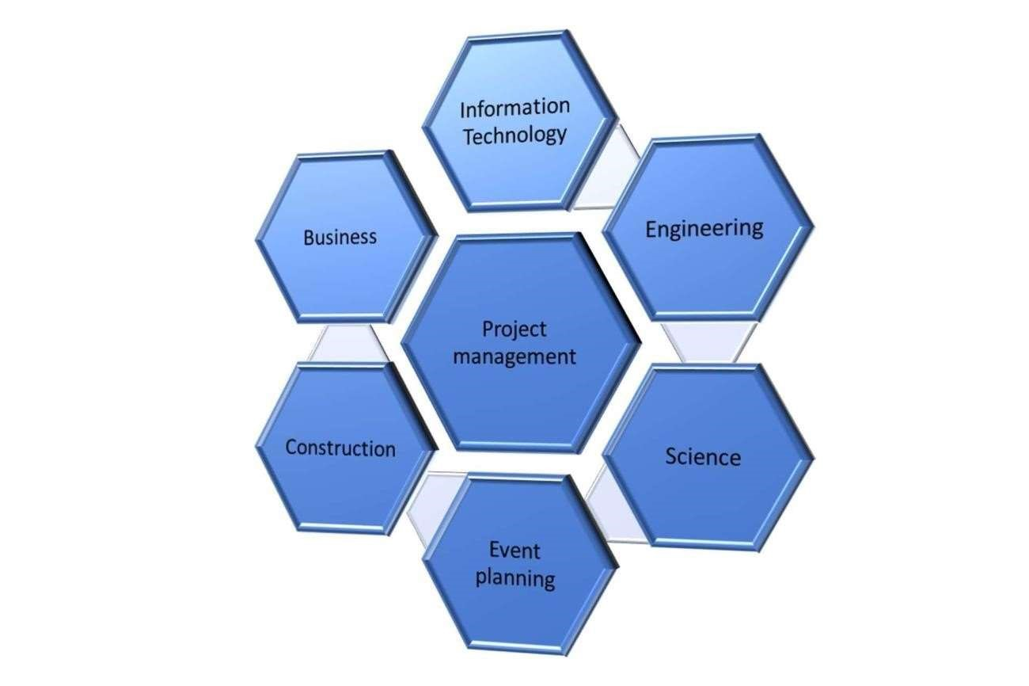

Project Management AM804001 Course Outline 2025

Table of Contents

Delivery details 3
Online help 3
Introduction 4
Learning outcomes 4
Otago Polytechnic’s Learner Capability framework 4
Blended delivery modes 4
Experiential learning approach 5
Attendance and participation 5
Electronic resources and Moodle components of course 6
Communication with your lecturer 6
Timetable 6
Timetable 7
Textbooks, readings and web resources 11
Authentic work experiences 11
Course evaluation 12
Assessments for this course 13
Assessment 1 – Individual Critical Review 15
Assessment 2 –Individual Report 16
Resubmissions 17
Assessment submission and due dates 17
Academic integrity/originality requirements 19
General information about assessments 20
Appendix 1 – Course Summary 22
Appendix 2 – Learner Capability Framework 24

Delivery details

Session times

Cohort | Lecturer | Day | Time | Location
C1 & C2 | Zagross Hadadian  zagross.hadadian@op.ac.nz | Monday &  Friday | 1:00 – 5:00pm & 8.30 am -12.30 pm | RM 201 Face-to-face
C3 | Olufemi Omisakin  olufemi.omisakin@op.ac.nz | Monday and Wednesday | 1:00 – 5 pm | RM 303  RM 302

Please note that attendance online will be logged in the same way it would in lecture time
Should you require assistance beyond the delivery model described in this outline, please discuss with your lecturer.

Online help
For assistance with online components of this course, there are three ways to obtain assistance:
Email: aicservicedesk@op.ac.nz and clearly describe the issue.
Phone the helpdesk at 0800111212.

Check Student Support Services through the OP website

Introduction

Haere mai, welcome to Project Management

The aim of this course is to:
Enable students to develop critical analysis and application skills in project management.

Learning outcomes

The approved course summary is provided in Appendix 1. This summary lists the learning outcomes and contains information about credit value, learning hours, and content of this course. Please read the course summary thoroughly.

These learning outcomes set out what you need to know or be able to do by the end of the course. Your achievement of the learning outcomes is measured through the assessments, which are detailed later in this document.

Otago Polytechnic’s Learner Capability framework

Otago Polytechnic’s Learner Capability Framework is provided in Appendix 2. Otago Polytechnic graduates are capable. This means they are ready for work (employment/self-employment). At Otago Polytechnic we define being ‘capable’ as being personally effective, future focused, and able to practice sustainably. This course and others in your programme will help you build on your existing capabilities and further develop these.

Blended delivery modes

All Otago Polytechnic ‘on campus’ programs are delivered through a blend of learning modes including face-to-face learning, online learning, authentic work experiences, and student managed learning.

Face-to-face learning is where students are physically present with others involved in the learning process, such as in a classroom or working with others in a student-managed project.

Online learning uses electronic technology to deliver learning materials and activities. Students can engage in online learning activities at the same time (synchronous) or they can engage with activities in their own time (asynchronous). All courses have a Moodle shell through which students can access course information including timetables, course-related messages and online learning activities.

Authentic work experiences cover a wide range of learning opportunities focused on work. These might be real work experiences, or they might be interactive learning activities that have been designed to replicate (as much as possible) the tasks, activities, or settings of real-world work. They are activities that are designed to ‘feel’ like a real workplace situation.

Student-managed learning can be in any mode; it is where students engage in learning activities without the presence of the teacher and are self-managing in order to complete the activity within the expected timeframe. The learning activities may be designed by a teacher but carried out by the students alone or in groups; for example, in a student-managed project, asynchronous online learning, or preparation of an assessment task. Student-managed learning can also be student-directed, whereby a student chooses to explore topics of interest to them as an adjunct to the formal learning designed by the teacher. The amount of student-managed learning expected will increase as you progress through the programme.
Not every course in your programme will necessarily blend all four learning modes, but the programme as a whole will provide components of each.

Experiential learning approach

At Otago Polytechnic we use an experiential learning approach. Experiential learning is learning through reflecting on experience within the context of your course and programme, including the face-to-face activities, online activities, and authentic work experiences that have been designed for each course.

Students engage in a learning cycle whereby they participate in an activity, reflect on that experience (think about it and ask questions about ‘what?’), explore abstract concepts (ideas, theory, and beliefs – ‘so what?’) and make connections (linking, relationships, and correlations - ‘now what?') between this theory and the learner’s actual experiences. Through this process new learning takes place and can then be applied to new activities and to work contexts.

Experiential learning will help you to develop critical-thinking skills and skills in reflection. It will also help you to think more deeply, to transfer your learning into action, and to be able to transfer learning from one situation to another. When students engage in ongoing cycles of experience/activity, reflection, conceptual thinking, and identification and application of learning, their learning is enhanced.

Attendance and participation

This programme is delivered over one block through a blended model that combines face to face sessions, online learning, authentic work experiences and student-managed learning activities. ‘To be successful it is expected that every learner will apply an average of 150 hours of learning to the course, through a combination of class time, tutorials, background research, work-related activity and assignment preparation and revision’.

In order to make the best use of learning opportunities, students are expected to attend all face-to-face learning opportunities and participate in all online learning activities including the online tutorials, all authentic work experiences and all student-managed learning activities. Failure to participate in all learning opportunities may compromise your learning.

To successfully complete this course, it is expected that every learner will apply an average of 150 hours of learning to the course, through a combination of class time, tutorials, background research, work-related activity and assignment preparation and revision activities.

You are required to attend all sessions, including any additional lectures and tutorials, according to your timetable.

International students are required to attend 100% of scheduled class time. Failure to meet this requirement may result in the student’s enrolment with Otago Polytechnic being terminated and Immigration New Zealand notified.
Lecturers are obliged to mark you as “late” if you enter the classroom 1 minute after the class starting time and “absent” if you enter 15 minutes after the class starting time or leave the class early. If you have legitimate reasons to explain your lateness and leave early, please bring your evidence to the Student Success team to update your attendance records.

If you are unable to attend class, you should inform the School through e-mail or telephone, to either the reception or the Course Lecturer, explaining your reason for absence prior to the class. You need to provide evidence (such as a medical certificate) to the Student Success team (Level 1) when you attend your next class. Please note that students who fail to attend a face-to-face study session without legitimate cause, or who have regular and unexplained absences, will be required to attend a meeting with Student Success and the Head of Department to establish a way forward. Failure to fulfil any required actions including attendance may result in exclusion and a notification to Immigration New Zealand may be necessary. You must advise in writing by letter, or by using the form available from the School reception, if you intend to take leave or withdraw from a course.

(Please see AP0710.05 International Student Attainment and Attendance Policy for full details) AP0710 International Learner Attainment and Attendance

Electronic resources and Moodle components of course

Information about all the learning activities you are expected to undertake in this course, including online activities, classroom activities, any workplace activities and any student managed learning activities, are available online.

The School has one main electronic resource, Moodle. Moodle contains course and assessment information, as well as course material such as readings and learning resources. It is important to understand and utilize this platform as it will aid your learning and enable you to access course information remotely. In addition to Moodle, the school has a Resource Centre where students are able to access newspapers, journals, and textbooks relating to business.

Communication with your lecturer

AIC always uses Otago Polytechnic Student email address and Moodle to communicate with you. These are your primary communication methods with the school. It is your responsibility to check your student.op.ac.nz email and Moodle daily. Only use this email to communicate with your lecturers and the school.

Timetable

The timetable below sets out the planned activities for each week. Keeping up to date with this will help you be prepared for the various learning activities you will be doing. Sometimes you will need to complete an online module before you come to class. There may also be an online tutorial or a discussion forum that builds on what you have covered in class. You will need to plan and manage your time to work on projects with others and to complete the required assessments.

The timetable below sets out the activities planned for each of the weeks timetabled for Project Management.

Timetable

Week beginning | Delivery mode | Topics | In Class Activities | Out of Class and Tutorial Activities
 | Week 1: In class (Public holiday for Tuesday class) | Introduction to the paper  Introduction to the project management industry answering the following questions:  What is a project?  What is a project plan?  What are the main professional organisations for project managers?  What is the role of the Project manager?  Introduction to Assessment 1 | Interactive understanding of the course, assessments and context of study | Define the difference  between the project management frameworks PMBOK and Prince2.  Define the difference between Agile and Traditional methodologies.
 | Self-directed learning and reading | Read the course outline  Complete Readings 1, 2, 3  Choose case study to work with  Spend time getting familiar with Project 2016 |  | Load Citrix server onto your own PC and ensure you have access to  Microsoft  Project 2016
 | Week 2: In class | Project Management Scope  Frameworks and methodologies  Defining and scoping the project begins with applying project framework and methodologies  Including project constraints or boundaries. | Project activity  Situation analysis Supported through group discussion | Produce a work breakdown structure for your chosen project on one A4 sheet in either Microsoft word or presentation
 | Self-directed learning and reading | Go through technical dictionary for the cases study chosen to familiarize yourself with industry terminology Reading 4,5,6,7 |  | Begin to learn  Microsoft Project  2016
 | Week 3: In class | Top-down planning: Producing a high-level scope.  Bottom-up planning: Parametric and PERT differences.  Group Methodology Presentation  Assessment 1 due on Friday 11.55pm | Presentation skills  Project activity  Analytical skills | Produce the scope for your chosen case study on no more than 2 sides of A4.  Using your WBS from week 2, develop 2 descriptive pages. One of the industry and technical standards needed for your project, and one of the stakeholders aligned to your project.
 | Self-directed learning and reading | Readings 8,9,10,11,12  Read protocols for working with  Maori  Tutorials for MS 2016 |  | Quiz No 1
 | Week 4: In class | Project Detail, work breakdown structure, networks, and Gantt chart Microsoft Project 2016 | Project activity  Analytical skills | Bathroom case study: qualitative and quantitative analysis
 | Self-directed learning and reading | Tutorials for MS 2016. Readings 13,14,15 | Software skills experiential learning  Problem solving  concepts | MS Project  Using your WBS from produce a professional high- level Gantt chart and network diagram, including dates, resources, and costs in MS Project.
 | Week 5: In class | Project estimating of time, cost, and resources.  3 point or PERT and Parametric practice | Quiz 2  Software skills experiential learning Problem solving concepts
 | Self-directed learning and  reading | Readings 16,17, 18 and 19 | Software skills experiential learning  Problem solving  concepts | MS Project  Using your WBS from produce a professional high- level Gantt chart and network diagram, including dates, resources, and costs in MS Project.
 | Week 6: In class | Project Risk, Variance and Performance Including:  Risk planning and mitigation  Reporting and planning variances  Reporting and planning performance | Identifying risks in all areas of the project as well as how to mitigate the risks. Using tables to identify and how to mitigate them.
 | Self-directed learning and reading | Upload a draft of your second assessment for review
 | Week 7: In class | Organisation Leadership and Teamwork and Project choice. | Project activity  Analytical skills | Myers Briggs leadership personality test.
 | Self-directed learning and reading | Readings 20 and 21
 | Week 8 In class | Quality Control, Procurement and Project Closure,  including:  How to define and control project quality  Project procurement and outsourcing  Project closure
 | Self-directed learning and reading | Assessment reviews in class  Assessment 2 Project Plan Due on Friday 11.55pm
 | Week 9 In class | Reflection and feed back

Textbooks, readings and web resources

Required texts There are no required texts for this course.

Recommended Reading
These readings are suggested to assist you to progress through this course in an informed way. This list is provided to guide your independent study and is not an exclusive list. These books can be accessed through the library.

Larson, E., & Gray, C. (2014). Project management: The managerial process (6th ed.). Boston: McGraw Hill.

Pinto, J. K. (2013). Project management – Achieving a competitive advantage (3rd ed.) New York: Pearson.

Kerzner, E. (2013) Project Management: A systems approach to Planning, Scheduling, and Controlling (11th Editions), Wiley. ISBN 978-1-118-02227-6

Fuller, M., Valacich, J., & George, J. (2010). Information system project management – A process and team approach. New York: Prentice Hall.

Brewer, J., & Dittman, K. (2013). Methods of IT project management (2nd ed.). New York: Prentice Hall.

Cadle, J., & Yeates, D. (2008). Project management for information systems (5th ed.) Harlow, UK: Pearson.

Schwalbe, K. (2014). Information technology project management (7th ed.) Boston: Course Technology.

Additional Resources
Academic papers are provided under each weeks topic.

Web Resources
Project Management Institute - www.pmi.org
Prince 2 - https://www.prince2.com/nzd/what-is-prince2

Authentic work experiences

Understanding and application of management methodologies within projects
Use of expert planning software
Production of an industry standard project plan

Course evaluation

This course will be evaluated by students and by the teaching team.

Students will be asked to evaluate the course via an online survey towards the end of the course. This can be completed any time after the halfway point of the course. This survey will be analyzed through the central institutional survey section of the polytechnic, and course coordinators will prepare a combined report that summarizes the findings of the survey and the reflections of the teaching team on the course as well as any changes they propose. This report will be made available to students online so they can see planned actions as a result of previous student feedback.

This report will also be considered by the teaching team when planning for the following year and any recommended changes will be implemented. Student feedback on courses is very important and helps us to ensure that courses meet students’ needs. Please help us by completing the online survey.

Assessments for this course
To pass this course you are required to achieve the course completion requirements set out below.
Assessments for this course
Course
Assessment Name/Typ | e Course completion requirements | Weighting | Due date and time | Learning  Outcomes | Scheme
1. Individual critical review | Upload into Moodle | 30% | Week 3 Friday  11. 59pm | 1 | Graded as below
2. Individual project plan report – 2 files, a word file and an MS project file | Upload into Moodle | 70% | Week 8 Friday  11.55pm | 1,2,3 | Graded as below

An overall mark of 50% is required to pass the course.
Grade | Definition
A+ | Met all course requirements – marks in range [90-100]
A | Met all course requirements – marks in range [85-89]
A- | Met all course requirements – marks in range [80-84]
B+ | Met all course requirements – marks in range [75-79]
B | Met all course requirements – marks in range [70-74]
B- | Met all course requirements – marks in range [65-69]
C+ | Met all course requirements – marks in range [60-64]
C | Met all course requirements – marks in range [55-59]
C- | Met all course requirements – marks in range [50-54]
 | Did not meet all course requirements. Mark in range [40-49] Could possibly qualify for a
D | Resubmission opportunity.
 | Did not meet course requirements. Mark in range [0-39] No Resubmission opportunity for
E | this range of marks.
Pass | Awarded pass and no appropriate grade can be awarded
Fail | Failed course and no appropriate grade can be awarded

Resubmissions

Students may be requested to resubmit an assessment following a rework of part/s of the original assessment. Resubmissions are completed within a short time frame (no more than five working days) and must be completed within the timing of the course to which the assessment relates. A resubmission does not count as a reassessment.

Assessment submission and due dates

Deadlines will be enforced, and any late assignments will be penalised. Ten percent (10%) will be subtracted for each day by which the assignment is late. Other than approved extensions, work handed in five or more days after the due date will not be marked and will result in the student failing the assessment. Extensions will be granted in only two circumstances:

- Medical grounds (a medical certificate is required)
- Compassionate grounds (outside the student’s control)

Please note holidays or other personal commitments or events are not considered appropriate grounds for sitting assessments (or submitting assessments) at different times. You must apply for an extension at least two days before the due date and negotiate a date for submitting your assessment with the lecturer(s) concerned.

Extension requests must be submitted in writing to the course facilitator at least 48 hours before the assessment deadline, excluding weekends. The assessment extension form can be found under the assessment tab on the Moodle course.

The request must clearly set out what the reasons are and provide supporting evidence. No request will be accepted without sufficient evidence.

Remarking
If a student believes there has been a mistake in marking, the student should in the first instance talk to the lecturer within 7 working days of the decision or result. If the student requests a remark of the assessment, another lecturer will be asked to do the second marking of the original work.

Appeals
Refer to AP0600 Academic Appeal Process for Learner policy for further details on the standard appeal process for learners. Students who believe they have been unjustly treated by any decision, action or omission in respect of the administration of policy should seek to have their complaint dealt with in accordance with the provisions of Policy AP0603 Resolution of Student Complaints. Support for this process is available through the Student Success Team on Level 1.

Student Support
The Student Success Team on Level 1 are available to assist students with accessing appropriate supports toward successful completion of courses. Peer tutors are available on Level 8 to assist with referencing and library access to information. There are free Academic English support sessions available to all students – check with your lecturer or the Student Success Team for specifics this Block.

Otago Polytechnic Policies
All Otago Polytechnic policies are available on https://www.op.ac.nz/about-us/governance- andmanagement/policies/

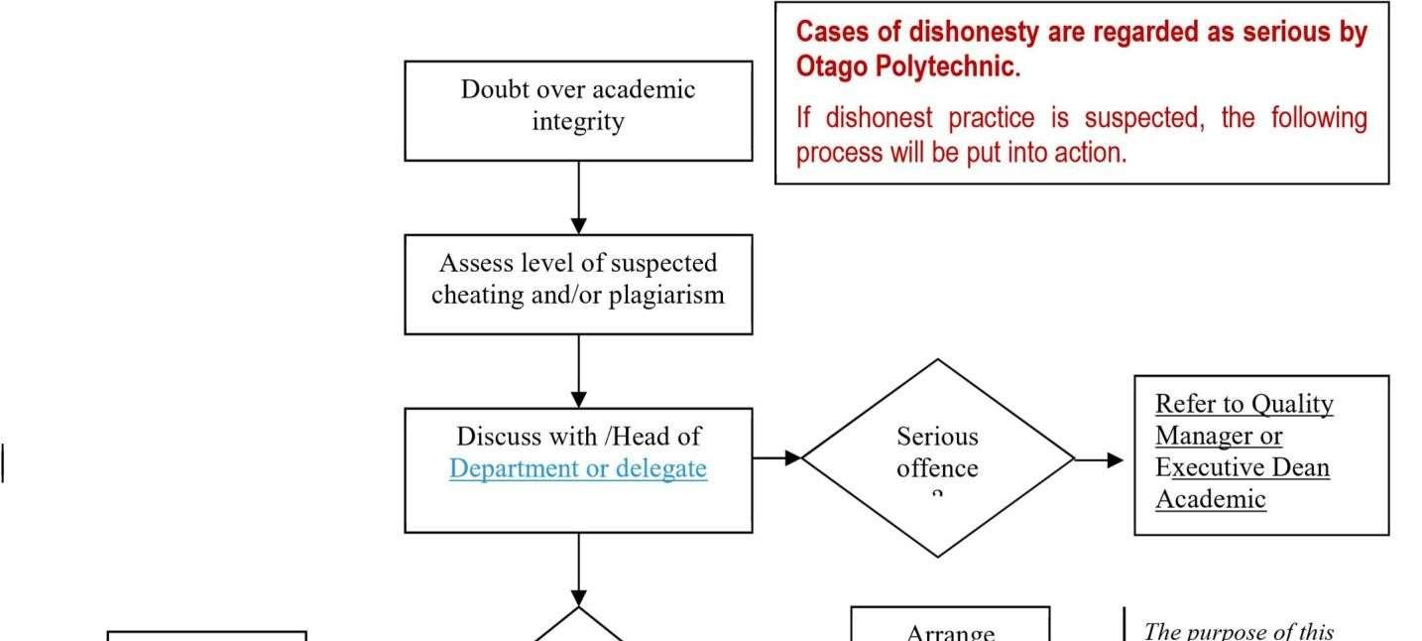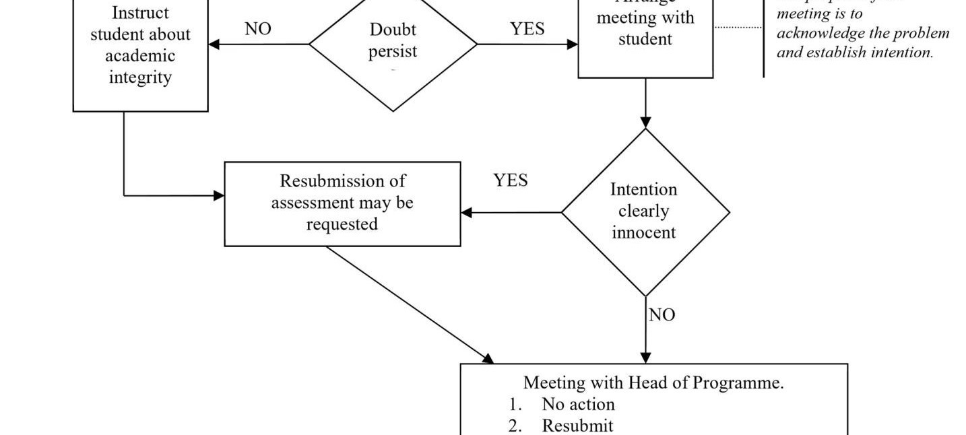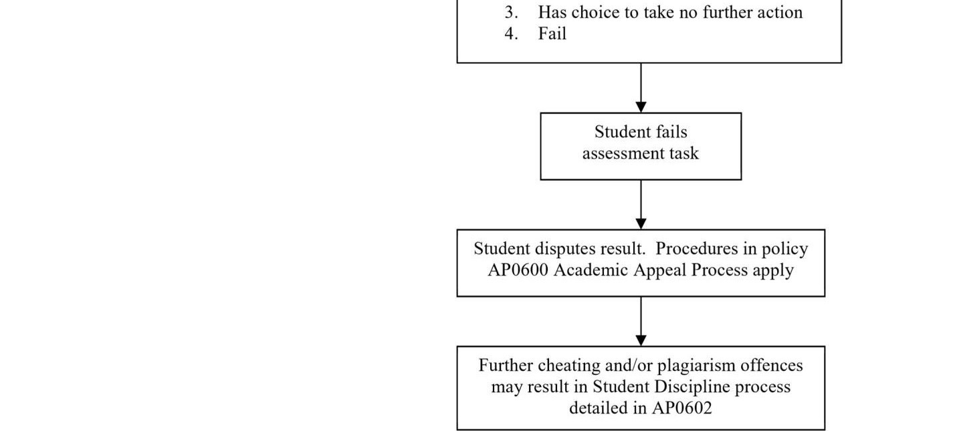

Academic integrity/originality requirements

The work that a student submits for assessment/grading must be the student’s own work, reflecting his or her learning.

Whenever you use ideas written by someone else in your assessments, you must acknowledge the source of this material. It is crucial that you understand the importance of respecting the intellectual property of other writers and researchers. All sources must be referenced using American Psychological Association (APA) format. If you do not acknowledge the material correctly, whether intentional or otherwise, you will be guilty of plagiarism which is considered a dishonest practice. Plagiarism will incur deductions depending on the severity of the ‘offence’ – these penalties range from original mark deductions, to percentage mark deductions, to a zero mark for the assignment. Refer to Otago Polytechnic Assessment and Moderation Policy AP900, and Plagiarism Policy AP607.00. Repeat infringements of this nature may result in exclusion from Otago Polytechnic Auckland International Campus.

Turnitin is an electronic plagiarism detection service that is used by educational institutions worldwide. When a student’s assignment is submitted electronically to this system it is matched against millions of internet pages, electronic journals and a constantly increasing database of previously and concurrently submitted assignments. Teaching staff receive a report from Turnitin that can be used as a resource to assist in making a judgement as to whether a student’s work is sufficiently original or contains material that has been plagiarised. Your lecturer may require you to submit your assessments to Turnitin (on Moodle) prior to submission, to check the level of originality in the submitted text.

The following table provides guidelines and actions for different Turnitin outcomes (similarities)

Outcome from Turnitin | Actions
Less than 10% | No action required
11% to 30% | Lecturer’s discretion - flexibility within the following limits  11-15% - up to 10% mark down  16-20% - up to 15% mark down  21-25% - up to 20% mark down  26-30% - up to 25% mark down
Greater than 30% | 1st instance – verbal warning from lecturer – resubmission required - up to 30% mark down  In all other cases – zero mark – disciplinary procedure

The disciplinary procedure will be

- Turnitin outcome is considered to be cheating/plagiarism and the lecturer must refer the student and outcome to the Associate Director, Learning and Teaching. The student is required to attend an interview, to be advised that the outcome of that assessment is zero, and that there are likely to be consequences on final results for the course.
- Student referred to Student Success for discussion and support so that this does not occur again.
- Plagiarism form to be completed and kept on the student file.
Sessions to help with APA referencing and integrating academic literature into your work will be held in each study block. You are expected to attend these sessions. Refer to the following websites for reference related resources:
- Auckland University: http://www.cite.auckland.ac.nz/index.php?p=quickcite
- Citation machine website: http://www.citationmachine.net/apa/cite-a-website
- Purdue University: http://owl.english.purdue.edu/owl/resource/560/06

The Otago Polytechnic Moodle site has resources to assist students on a number of topics under the Learning Support tab in Moodle.
https://studentservices.op.ac.nz/learning-support/

General information about assessments

Submissions
Assessments such as reports, assignments, etc. are to be submitted electronically (unless advised otherwise) naming each one as follows in the subject line: your name followed by abbreviation for paper then the number of the assessment, e.g. LukeCapMgrs1.
Students must use appropriate cover sheet for all assessment items.
Return of assessments Marked assignments will be returned to students no later than ten days after submission.

Assignment extensions
We strongly encourage you to develop good study skills, including planning your study load to meet the required deadlines. Extensions may be granted at the discretion of the course coordinator. Refer to the relevant section in the Assessments module online as each school has specific and different processes for managing extensions. Assignment extensions must be negotiated with the course coordinator concerned at least two working days before the assignment due date and be documented as per relevant school requirements. Extensions cannot be granted for presentations that are scheduled during the study blocks or by video conference or Adobe sessions. Be aware that gaining an extension will compound the workload in the following weeks or reduce study time.

Failure to meet assignment due date
The course coordinator must receive assignments by the scheduled time and date except when an application for an extension has been granted by the course coordinator.

Resubmissions
Students may be requested to resubmit an assessment following a rework of part/s of the original assessment. Resubmissions are completed within a short time frame (no more than five working days) and must be completed within the timing of the course to which the assessment relates. A resubmission does not count as a reassessment.

Failure to pass the course
Students who do not meet the requirements to pass this course (as outlined in the assessment section above) must contact the course coordinator to discuss the implications and any next steps. Institutional policy allows students to enrol in any one course a maximum of three times. Any exceptions to this must have been approved by Academic Board and detailed in the programme document.

Appendix 1 – Course Summary

Project Management
SMS Code | AM804001 | Teacher-directed learning hours | 32
Level | 8 | Authentic work experience learning hours | nil
Credits | 15 | Student-managed learning hours | 118
Prerequisites | Nil | Total Learning Hours | 150
This course is compulsory for the Postgraduate Diploma in Applied Management and the Master of Applied Management
Aim
To enable students to apply and critically analyse project management skills and practices in an organisational context.
Learning Outcomes
On successful completion of this course students will be able to:
- Critically assess project management methodologies and select a suitable methodology for a specific organisational project in the Aotearoa New Zealand context.
- Critically apply estimation techniques and develop planning and scheduling processes to minimise costs and risks for a project.
- Critically analyse the role of project management in achieving successful outcomes for a major project.
Indicative Content
- Stages of project management
- Project management methodologies
- Key planning activities and processes required to undertake successful projects, such as relationship building and appropriate consultation
- Reasons for success and failure of projects
- Cost, time, personnel, quality and external factors
- Estimation, planning and scheduling
- Change management and risk management
- Application of specific Māori values such as, but not limited to: kaitiakitanga (guardianship), manaakitanga (generosity/hospitality), whanaungatanga (relationship/kinship), whakamanatanga (empowerment) and takohanga (accountability) within Aotearoa/New Zealand organisations.
Assessment
Assessment Activity | Weighting | Learning Outcomes
Assignment 1 | 30% | 1
Assignment 2 | 70% | 1, 2, 3
NOTE: The requirements of Iwi/Māori organisations should be included in the project management plan.
Resources
Brewer, J., & Dittman, K. (2013). Methods of IT project management (2nd ed.). New York: Prentice Hall.
Cadle, J., & Yeates, D. (2008). Project management for information systems (5th ed.) Harlow, UK: Pearson.
Fuller, M., Valacich, J., & George, J. (2010). Information system project management – A process and team approach. New York: Prentice Hall.
Larson, E., & Gray, C. (2014). Project management: The managerial process (6th ed.). Boston: McGraw Hill.
Pinto, J. K. (2013). Project management – Achieving a competitive advantage (3rd ed.) New York: Pearson.
Schwalbe, K. (2014). Information technology project management (7th ed.) Boston: Course Technology.

Appendix 2 – Learner Capability Framework

Otago Polytechnic Learner Capability Framework as at January 2016

Otago Polytechnic graduates are capable. This means they are ready for work
(employment/self-employment). At Otago Polytechnic we define being ‘capable’ as being personally effective, future focused, and able to practise sustainably.
This course will develop the relevant characteristics of being capable from the list below.

In authentic work experiences the learner is able to:

- Effectively communicate in writing
- Effectively communicate with other people
- Effectively communicate in presentations
- Demonstrate cultural competence
- Work independently
- Work in teams
- Be reflective
- Be responsible
- Comply with Health & Safety
- Demonstrate digital competence
- Be resilient
- Demonstrate forward thinking
- Be creative and innovative
- Demonstrate leadership
- Be enterprising
- Practise sustainably
- Practise ethically
- Think critically
- Solve problems

